**How to connect MS SQL Server to MS Power BI**

Written On: October 19th 2025

A quick guide on how to import a table from MS SQL Server into MS Power BI App. Taken from [this Microsoft article](https://learn.microsoft.com/en-us/power-bi/connect-data/service-gateway-sql-tutorial)

***Step 1:*** Retrieve the server name from which our SQL database is stored in.

This can be done in one of three different ways, each of which will yield the same result.

1. When you first open **SQL Server Management Studio (SSMS)**, a **"Connect to Server"** dialog box (a pop-up window) appears. In that window, the "Server name" field is pre-filled with the most recently used server, or you can also access a dropdown list of previously connected servers.

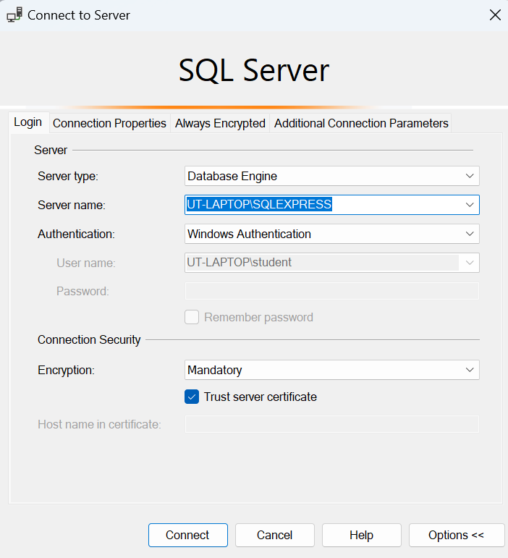

My server name is: UT-LAPTOP\SQLEXPRESS

Now, if you're already connected to a server and would like to know which server you're using, there are two ways to go about it:

1. In a new query window, run this query:

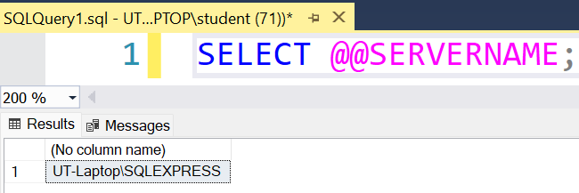SELECT @@SERVERNAME;

1. You can also view the server name in the Object Explorer pane, or by right-clicking on the server name, selecting 'Properties,' and then checking the 'Name' field in the pop-up window."

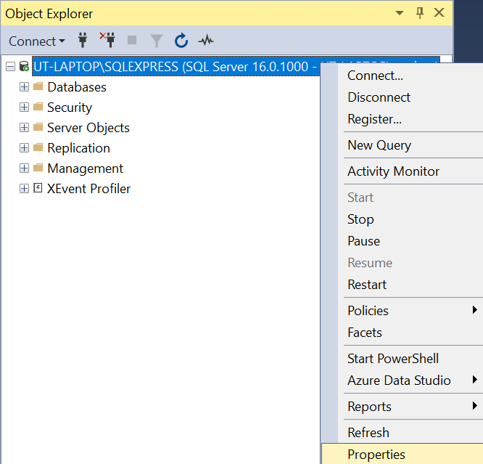

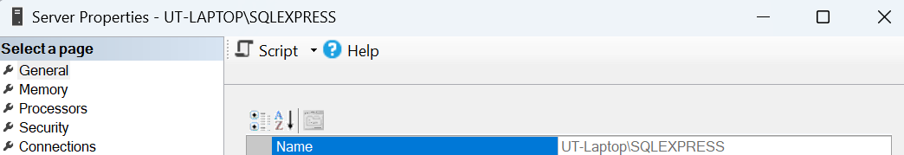

***Step 2:*** Once you’ve retrieved the server name, it’s now time to import it.   
NOTE: SQL Server Management Studio (SSMS) doesn’t need to be open to import data into Power BI from SQL Server.

Open Power BI Desktop. I’ll open a blank report, and from the **Home** tab, select **SQL Server**

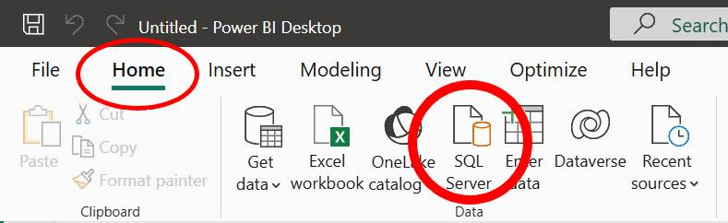

***Step 3:***

In the **SQL Server database** dialog box, enter the **Server** and **Database (optional)** names

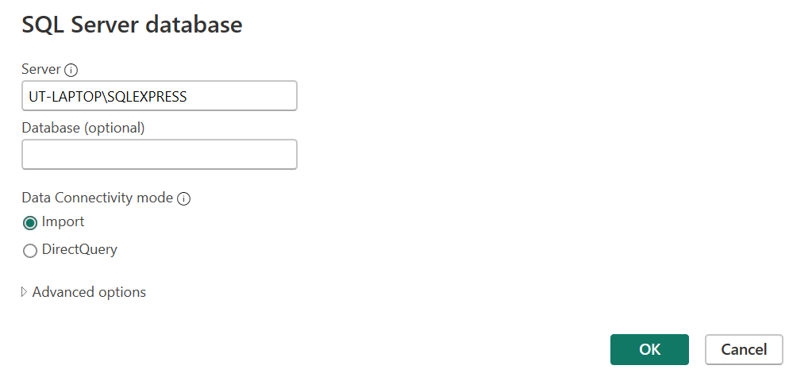

When importing data in Power BI, under **Data Connectivity mode**, you will be asked whether you’d like to use **Import** or **DirectQuery**. *For the purposes of this guide, we'll set the Data Connectivity mode to ‘Import’ & select ‘OK’* but the differences between the two are highlighted in this table:

Aspect Import DirectQuery

Data storage Data is copied and stored in Power BI Not stored since queries are sent live to source

Performance Faster since data is local & internal Slower, depends on source & network speed.

Data freshness Static until manual or scheduled refresh Always current & up-to-date

What is it best for? Smaller data, fast interaction, rare updates Large data, real-time needs

***Step 4:***

We might be asked to verify our credentials, especially if you’re using this connector for the first time. I’ll simply select “Connect”.

***Step 5:***

In the **Navigator** dialog box, select the table you’d like to import and then select **Load**.

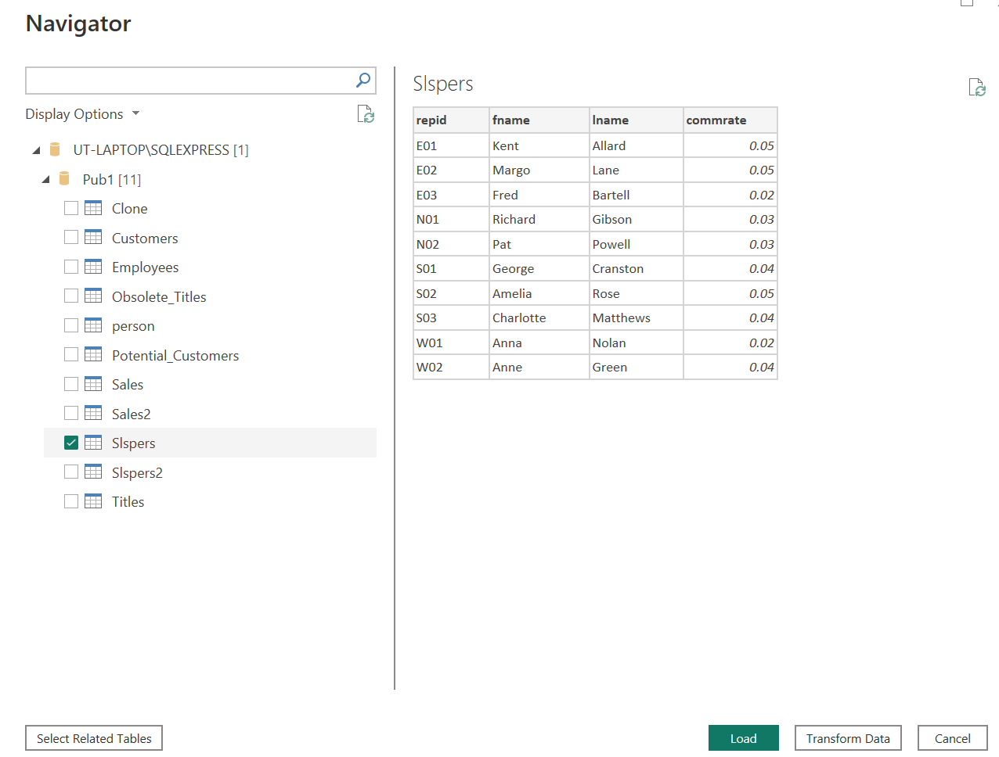

**Result:** The table should now be imported into Power BI.